St. Joseph’s Primary School
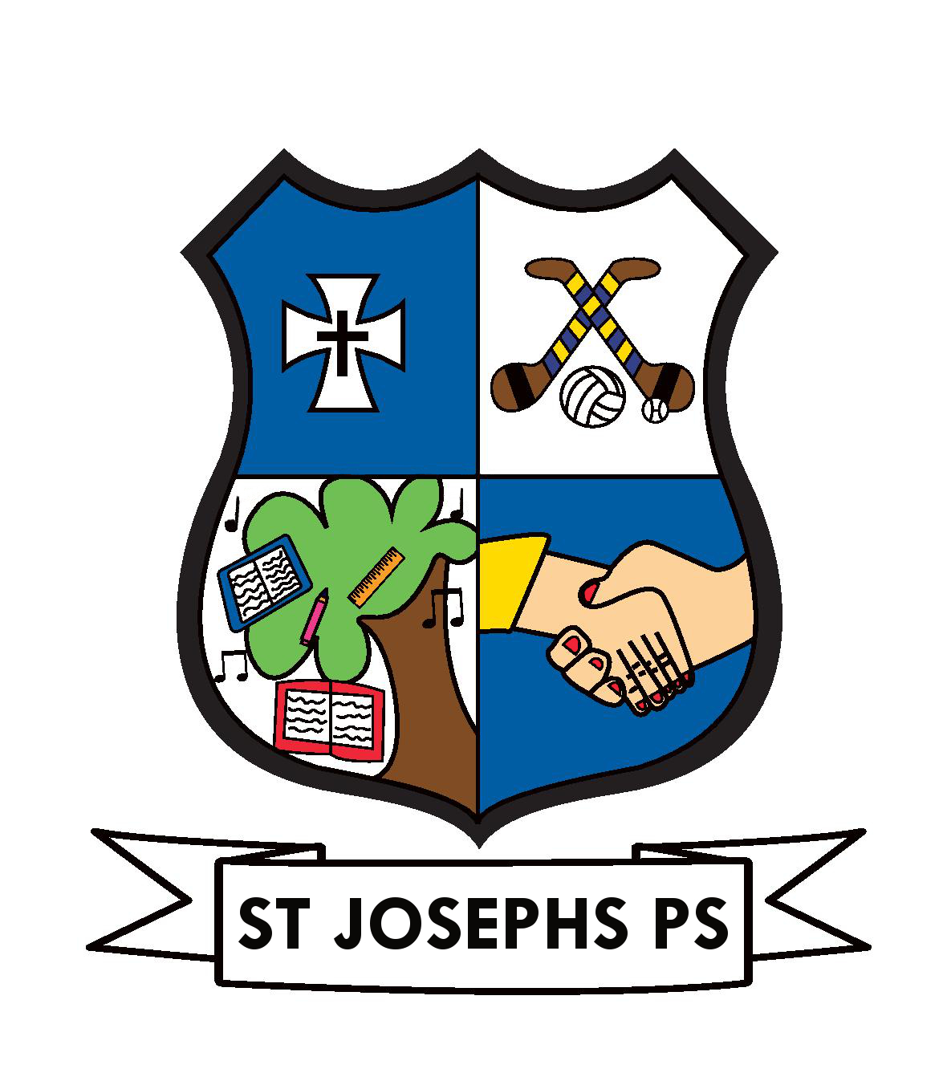
ANNUAL ADMISSION NOTICE
in respect of admissions to the 2026/2027 school year

Admission Policy and Application Form
A copy of the school’s Admission Policy and the Application Form for Admission for the 2026-2027 school year is available as follows: –
To download at: www.stjosephstemplemore.ie
On request: By emailing principal@stjosephstemplemore.ie or writing to:
St. Joseph’s Primary School, Templemore, Co. Tipperary, E41W132

PART 1 - Admissions to the 2026/2027 school year

Application and Decision Dates for admission to 2026-2027 school year

The following are the dates applicable for admission to Junior Infants

The school will commence accepting applications for admission on | January 26th 2026
The school shall cease accepting applications for admission on | Feb 16th 2026
The date by which applicants will be notified of the decision on their application to Mainstream/ASD class | March 6th 2026
The period within which applicants must confirm acceptance of an offer of admission is | 3 weeks  (March 27th 2026)

*Failure to accept an offer within the prescribed period above may result in the offer being withdrawn
Note: the school will consider and issue decisions on late applications in accordance with the school’s admission policy.

Special Class Application and Decision Dates for admission to the 2026-2027 school year
The following are the dates applicable for admission to the school’s special class which caters for children with Autism.

The school will commence accepting applications for admission to the special class on | Monday, December 15th 2025
The school shall cease accepting applications for admission to the special class on | Friday, January 16th  2026
The date by which applicants will be notified of the decision on their application for admission to the special class is | Friday, February 6th 2026
The period within which applicants must confirm acceptance of an offer of admission to the special class is* | Friday, February 27th2026

*Failure to accept an offer within the prescribed period above may result in the offer being withdrawn.

Number of places being made available in 2026/2027 school year

The number of places being made available in Junior Infants is | 40 (20 x 2)
The number of places being made available in Seoda/ASD Class is | 2

