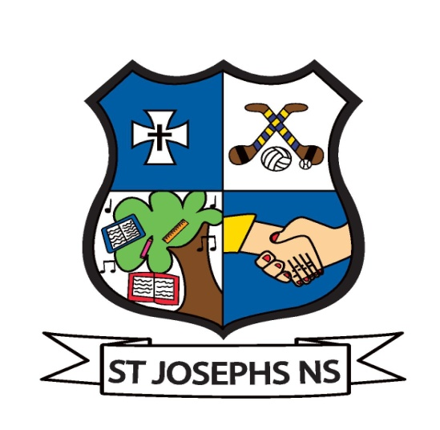
St. Joseph’s Primary School,
Templemore,
Co. Tipperary.
Telephone: 0504-31141
E-mail: principal@stjosephstemplemore.ie
Website: www.stjosephstemplemore.ie
Twitter: @StJosephs_PS

Wwww

W

St. Joseph’s P.S.

18th January 2021,

Dear Parent,

Here below please find Enrolment Application Form – 2021/2022 for your son/daughter.

This is the initial form in the process of enrolling your child for the coming school year.

Please return completed form on or before Friday 12th February 2021.

Should your application be accepted, you will then receive a letter of offer. This will also include a registration form, privacy notice, consent forms as well as Enrolment and Acceptable Use Policies.

Information Evening for Parents of incoming new pupils will take place
in due course.

This can be a very exciting and sometimes anxious time in your child’s educational journey, so please do not hesitate to contact me at any time should you wish to discuss any aspect of your child’s enrolment here in St. Joseph’s.

Yours sincerely,

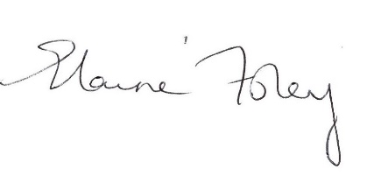
__________________________
Elaine Foley,
Principal.

