Thomas MacDonagh in the Easter Rising

Tipperary born Thomas MacDonagh was an important figure in the 1916 Easter Rising.
He was one of the 7 leaders who signed the Proclamation which was presented on April 24th, 1916.

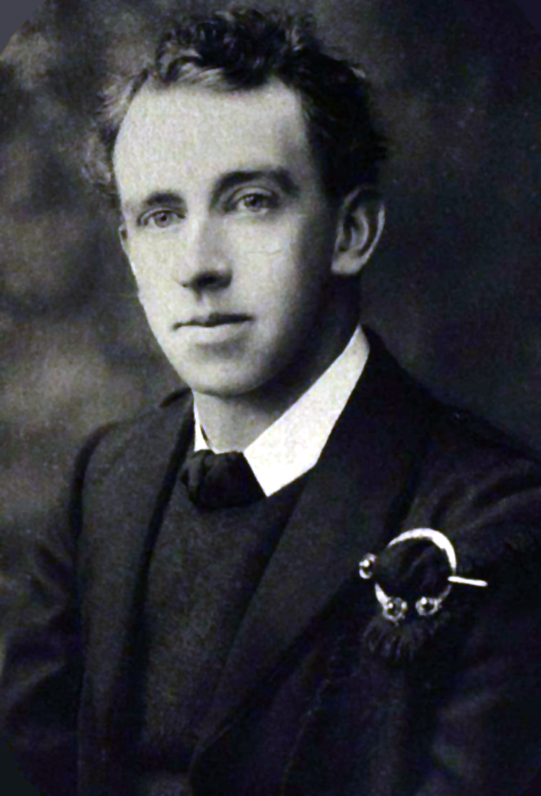

Republicanism:

In 1913 both MacDonagh and Joseph Plunkett (another leader) attended the inaugural meeting of the Irish Volunteers and joined its Provisional Committee.
Macdonagh was later appointed Commandant of Dublin’s Second Battalion, and eventually made commandant of the entire Dublin Brigade.
Although originally a pure constitutionalist, through his dealings with men such as Padraig Pearse, Joseph Plunkett, and Sean MacDermott, and through the increasing militarisation of Europe in the onset of World War 1, Macdonagh developed stronger Republican beliefs, joining the IRB (Irish Republican Brotherhood), probably during the summer of 1915.
Around this time Tom Clarke asked him to plan the grandiose funeral of Jeremiah O’Donovan Rossa, which was a resounding propaganda success, largely due to the graveside oration delivered by Pearse.

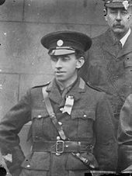

Easter Rising:
Though credited as one of the Easter Rising’s seven leaders, MacDonagh was a late addition to that group.
He didn’t join the Military Council that planned the Rising until April 1916, just weeks before the Rising took place. The reason for his admittance at such a late date is uncertain.
Still a relative newcomer to the IRB, men such as Clarke may have been hesitant to elevate him to such a high position too soon, which raises the question as to why he should be admitted at all. His close ties to Pearse and Plunkett may have been the cause, as well as his position as Commandant of the Dublin Brigade (though his position would be later superseded by James Connolly as Commandant-General of the Dublin Division). Nevertheless, MacDonagh was a signatory of the Proclamation of the Republic.

During the Rising, MacDonagh’s battalion was stationed at the massive complex of the Jacob’s Biscuit Factory. On the way to this destination, the battalion encountered the veteran Fenian, John MacBride, who on the spot joined the battalion as second-in-command, and in fact took over part of the command throughout Easter Week, although he had no prior knowledge and was in the area by accident. MacDonagh’s original second-in-command was Michael O’Hanrahan.

As it was, despite MacDonagh’s rank and the fact that he commanded one of the strongest battalions, they saw little fighting, as the British Army avoided the factory as they established positions in central Dublin. MacDonagh received the order to surrender on April 30th, though his entire battalion was fully prepared to continue the engagement.
Following the surrender, MacDonagh was court martialled, and executed by firing squad on the 3rd of May 1916, aged 38, in Kilmainham Gaol. He was the 3rd signatory of the Proclamation to be shot. It is said that as he was taken from his cell to be executed, he whistled.

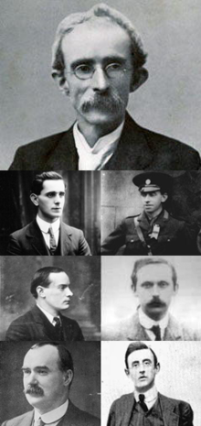
Top: Thomas J. Clarke
2nd Row Left: Sean Mac Diarmada
2nd Row Right: Thomas MacDonagh
3rd Row Left: Padraig Pearse
3rd Row Right: Eamonn Ceannt
4th Row Left: James Connolly
4th Row Right: Joseph Plunkett

In Honour of Thomas MacDonagh:

To this day, there remain memorials in honour of MacDonagh.
In Cloughjordan (his hometown), there is a beautiful memorial garden and museum about him.
The Thomas MacDonagh Pipe Band in Templemore is in memory of this battalion. And MacDonagh Terrace across from our school is probably a memory of him too.

II